Web Application

Team Project

REPORT

Choi Jaeyoung

Kwon Jaehoon

Park Jaehoon

Seo Geurim

HERS_Hanyang Erica Rental Site

**[1] Abstract**

It is a Web application that implements ‘ Footboard and Gymnasium Reservation ’, which can be booked on the wanted time to reserve a book on the desired time frame, instead of having to book directly through the document. A reservation system can only be used when a user is logged in after registering to avoid the use cases, such as making multiple reservations or not appearing during the post-booking hours. About the page, you have introduced a webpage introduction, a comprehensive booking method, and a system introduction, allowing users to use the page much easier. The booking process consists of selecting a site, selecting the date of reservation, selecting the date of reservation, selecting the schedule, choosing whether to use it, and entering the name of the appointment. If you want to advertise your competition, the notice function can inform other users of your competition. In addition, matching systems will only be made to reservations two weeks after the current date. This allows users to play game games.

**[2] Problem Specification**

Subject : Futsal Rental Management System

- Schools now manage the rental of futsalfield and ground through paper.

There is a downside to the inconvenience that rental management via documents should be written in designated locations within designated time periods. This creates time, space constraints, and can also recall the problem of lost documents.

To compensate for these problems, deploying online systems through web applications, eliminating temporal constraints, and storing written data on documents written in the database have resulted in a much simpler rented management system.

>Examples of legacy rental management systems

- Webpage University homepage lockingclocking notebook / space

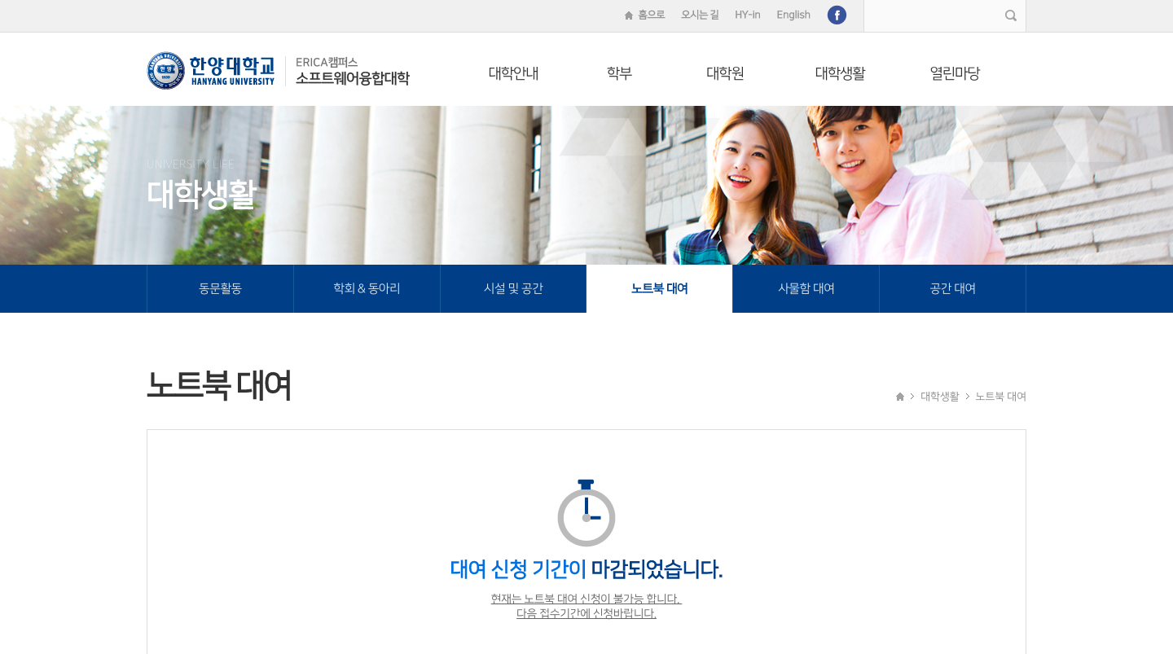

Rental subscriptions for rental systems (notebook / locker) in the classroom are being accessed via web homepages. This is very effective in managing rental applications and processing data for many students.

>Special points compared to traditional rental management systems

- Notice function

This is a function that enables the user to make a reservation and, if they want to do so, post their competition on a web page according to the specific competition date. This function enables page visitors to know which events are played on the day and also gives them an opportunity to watch the events. By adding these functions to the simple rental management web page, users can be more community-oriented and receive users who are interested in soccer or footsall as users.  
- Matching function

This function is very useful when it comes to the characteristics of sports events called soccer. Football basically requires two teams to play, but when you want to play a game but can't find an opponent, the Matching function plays to save the other team. This function will be performed by pressing the Save Team button when the user pushes the reservation. Matching features allow users to be directly assisted and proactive by having a web page with passive features that only makes reservations.

**[3] Web Application Design and Implementation**

**1. Front End**

1-1. Design

(1) Main Page, Menu bar

When you enter a webpage, it is the first screen you see. The whole screen was designed to reflect what this webpage should look like and what features they have. It had the effect of changing the background image every 6 seconds to give it flexibility. The effects of changing the background image were brought to an open source.The background images showed users using a screen that showed soccer stadiums, four screens that represented soccer teams who wanted to play soccer, and four screens that represented the game. It adds flexibility by placing animations in the text that outlines the function of the site title, web page, and on the button that goes to the confirmation of reservation / reservation progress screen. At the top left, the menu bar was added to enable the spread of the menu bar. Touch the icon to display the menu bar sliding from left to right. The menu bar has arranged menus that allow you to move to home, to pages, to the login menu, to the login menu, and to the Appointment Book page. If you want to replace the expanded menu bar, simply press the X icon that appears when you open the menu bar. Touch this icon to slide the menu bar from right to left again and disappear. At the bottom of the page, the page was given a small page name and the name of the developers.

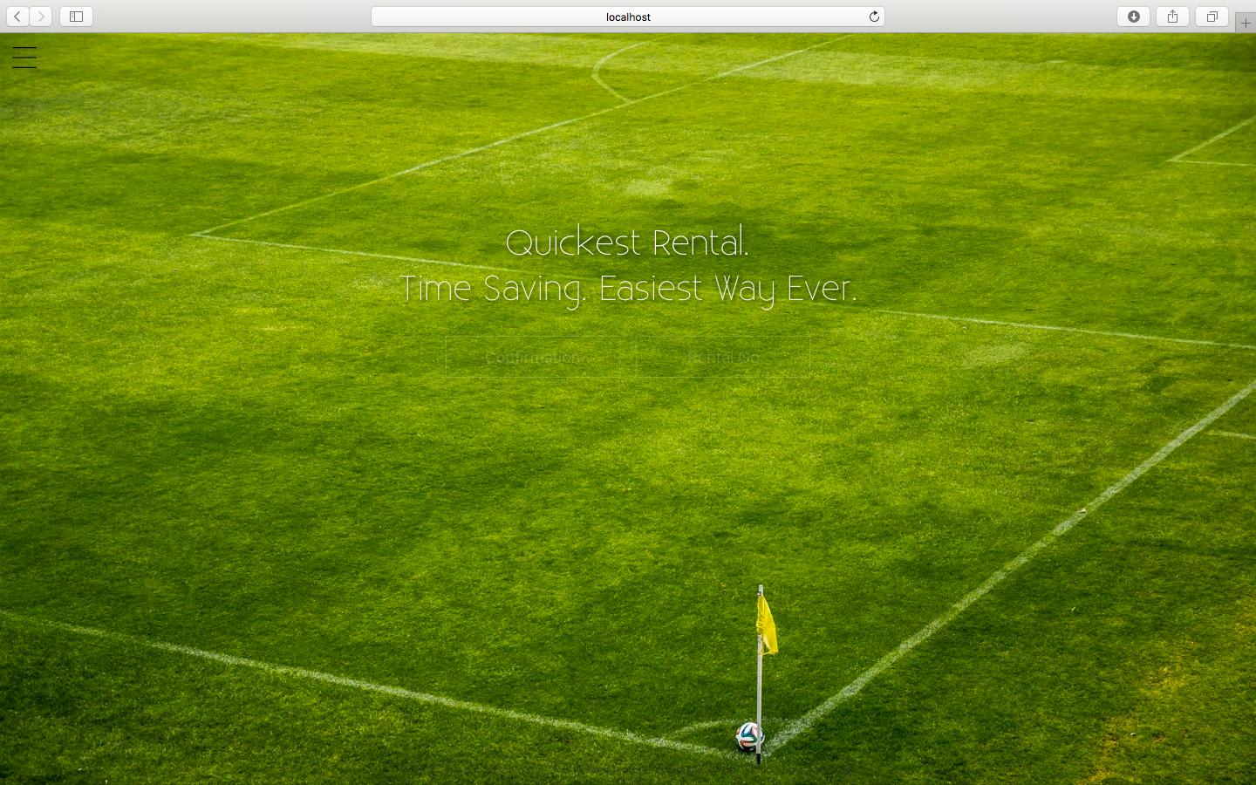

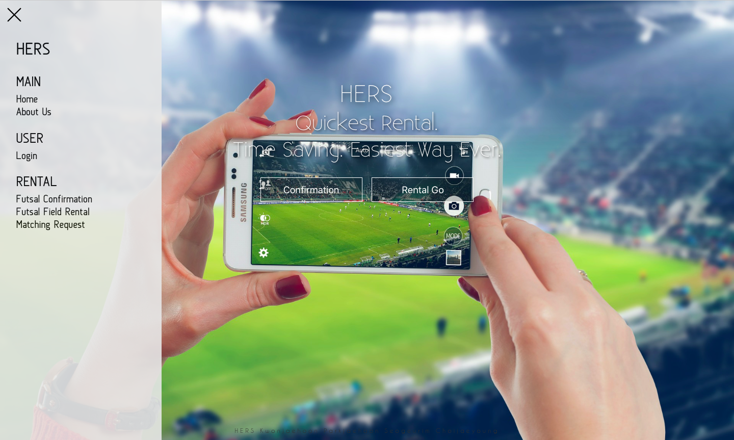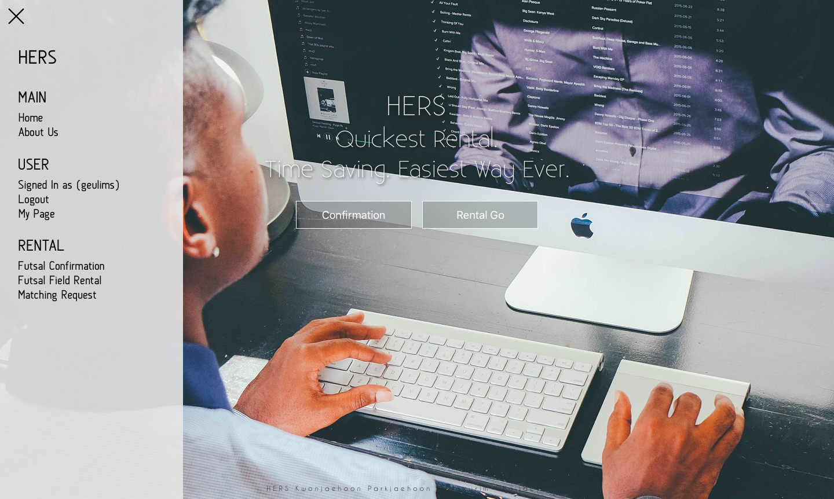

(2) Sub Pages

Put the menu bar on all subpoenas to allow users to move to different pages via various menus at all times. At the top of the page, we put a page title on the top of the page, and then clicked the title to return to the home. The background wallpaper provided background related to soccer.

(3) Login / Sign Up / Forgot

In every input box for login, membership, and ID / Password search, you wrote the Hilarwolder via placeholder. At the bottom of the login screen, each member of the log-in screen has a link to enter the screen, password, and search screen. The animation on the screen was shown to show the animation effect when the button was raised by the button on each screen using the navigation and transport ID! Each of the windows consisted of a card format and was placed in the middle of the background screen.

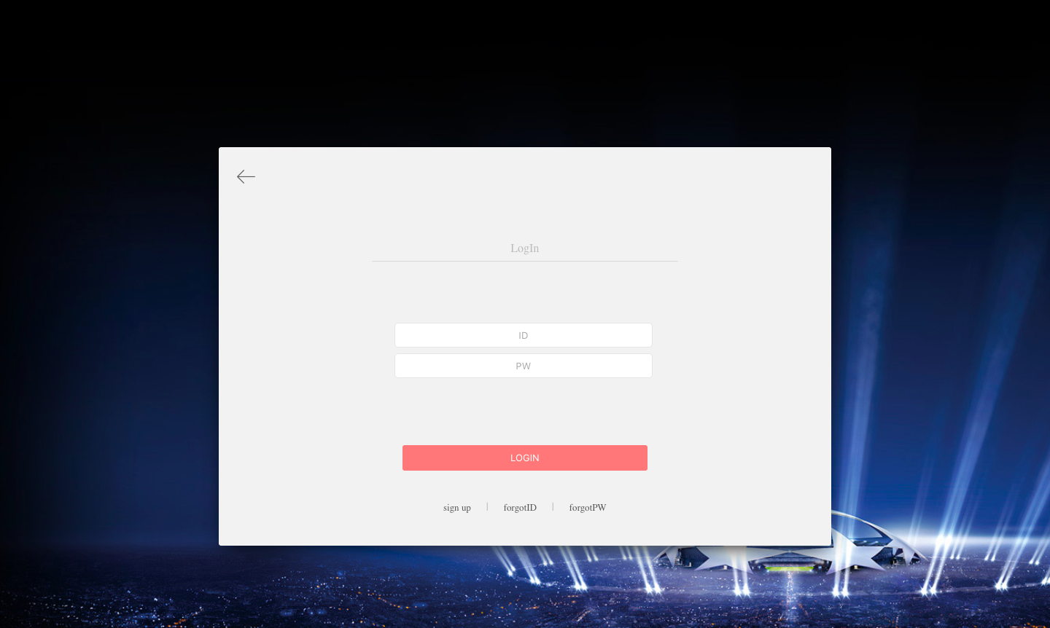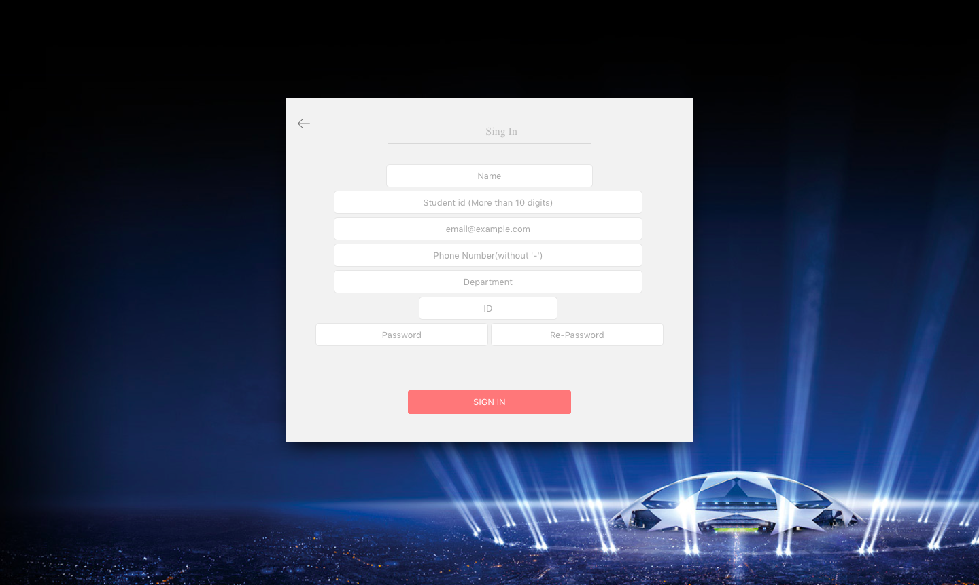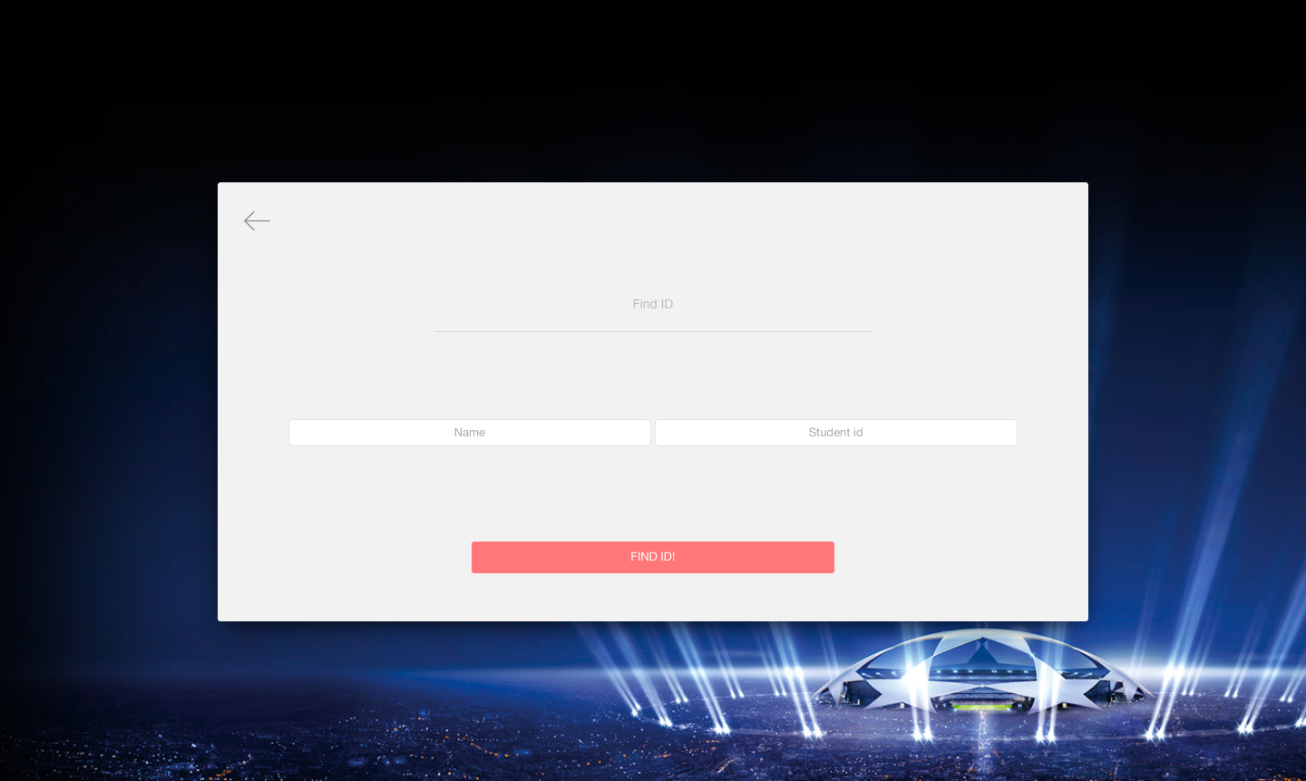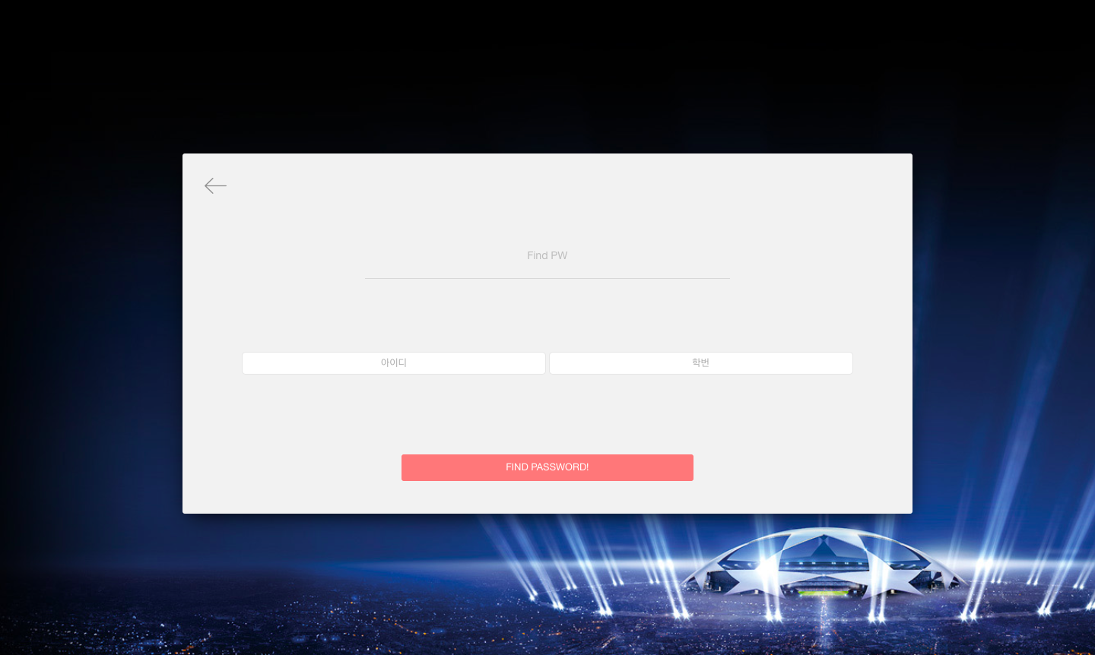

(4) About Us

This page has three sub-titles : Site Informations, Developers, and Contact. Below the title of the top of the page you can view the menu for this subtitle. Click on each menu link to automatically scroll to the division that has the corresponding subhead. All of this information is contained in a white card form, and when the page enters the page, it comes up from underneath the page. We also set the top title (header) to fade out when we scroll down by clicking each menu for sub-titles. The clock icon, which represents 24 hours in the middle of the middle, emphasized that it was a very efficient page when our webpage considered time and space constraints. Animation is all done with jquery.

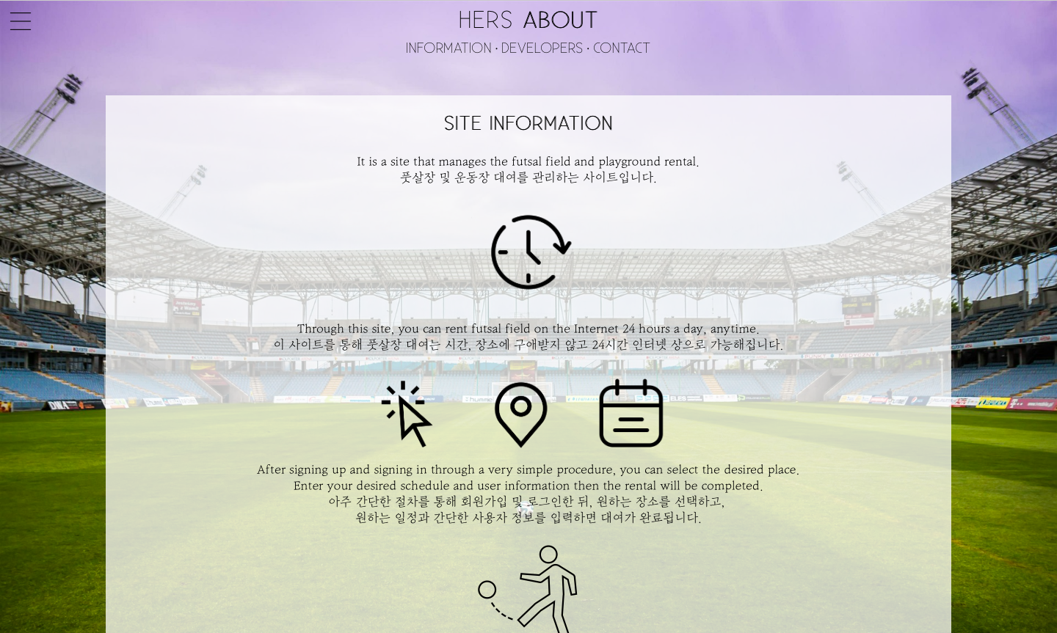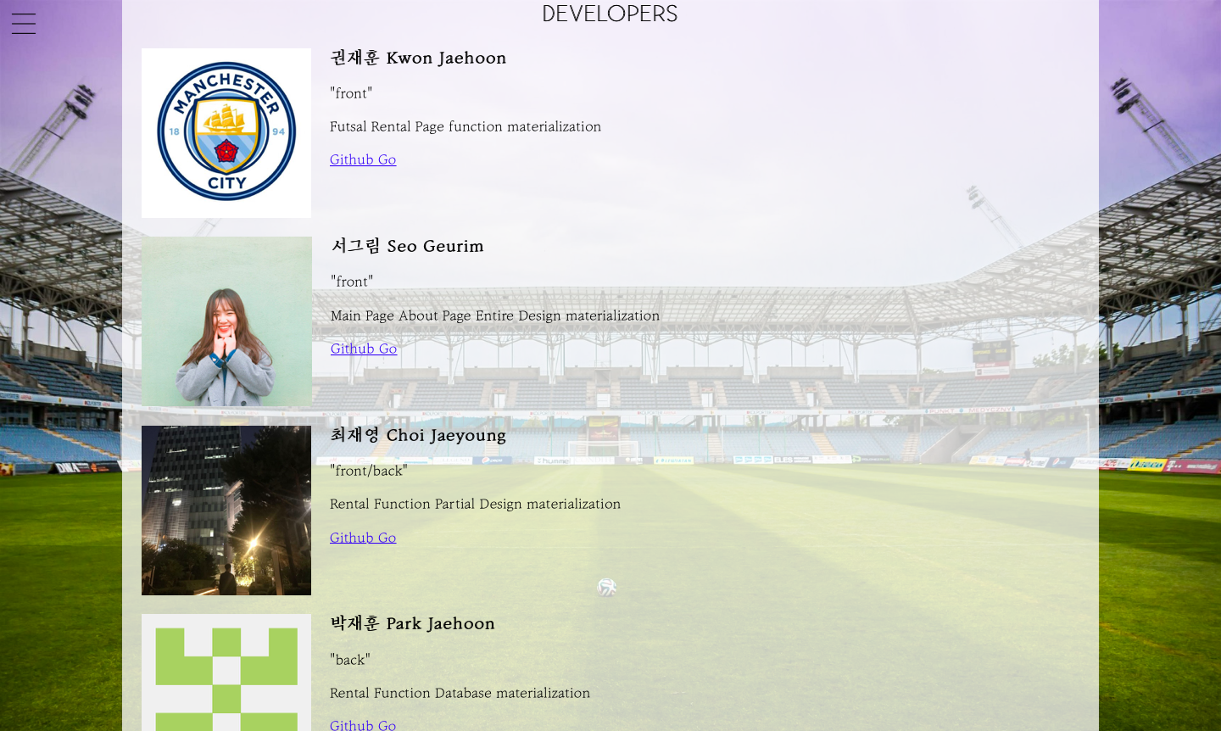

(5) Futsal Field Rental Page

I placed the card in the middle of the background screen and put it inside. On top of that, we added a week's weather to the top, which is open source.) The users can see what the weather is like on any day they want to play. At the bottom, the school was allowed to select a school floor to choose a place where it was located. The map captured the following map images, followed by a single line with each line of Adobe Illustrator, and stored as a vector image by clicking the vector image of an object. Popup events were implemented with JavaScript. Buttons in the popup also had an animation effect when calling using JavaScript. At the top of the screen, teams who wanted to make an announcement on today's date were shown playing a game in which the notice of the game slowly scrolls up one line.

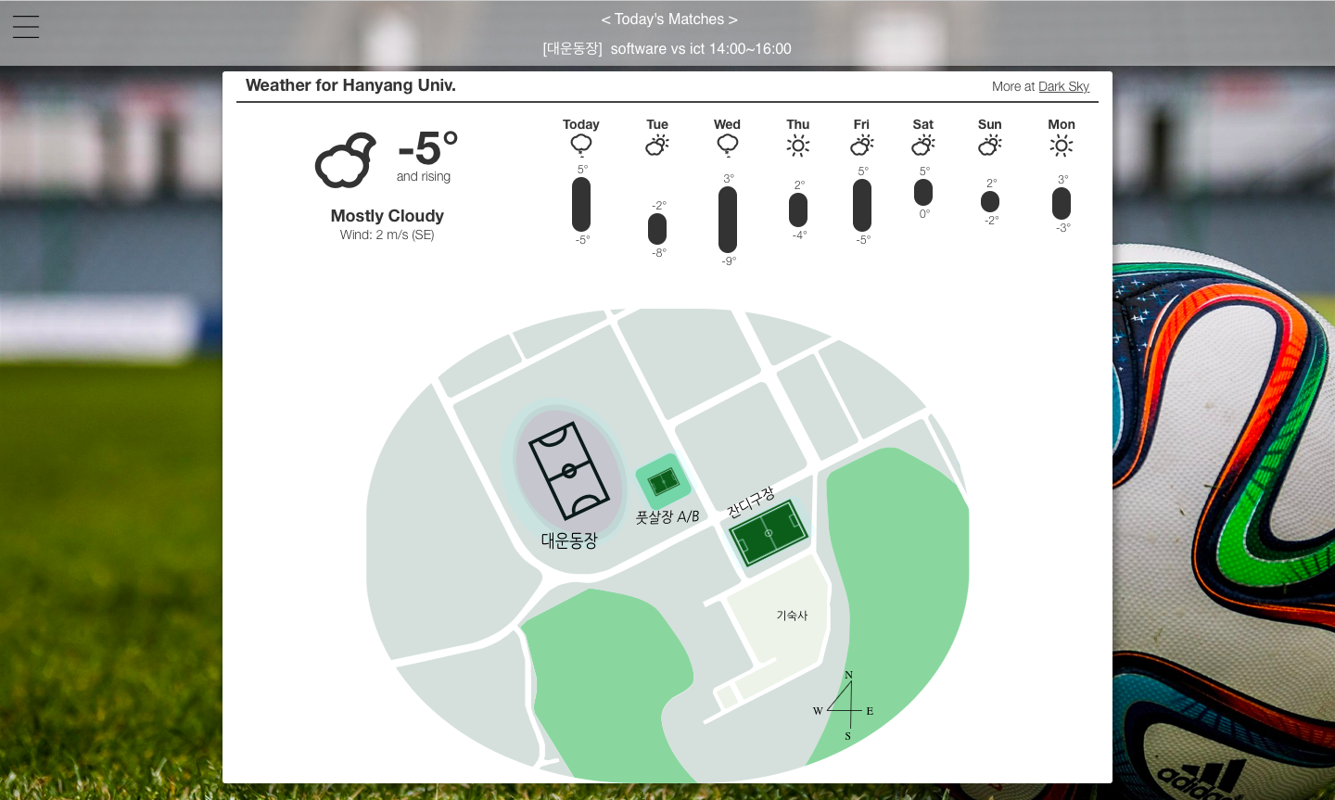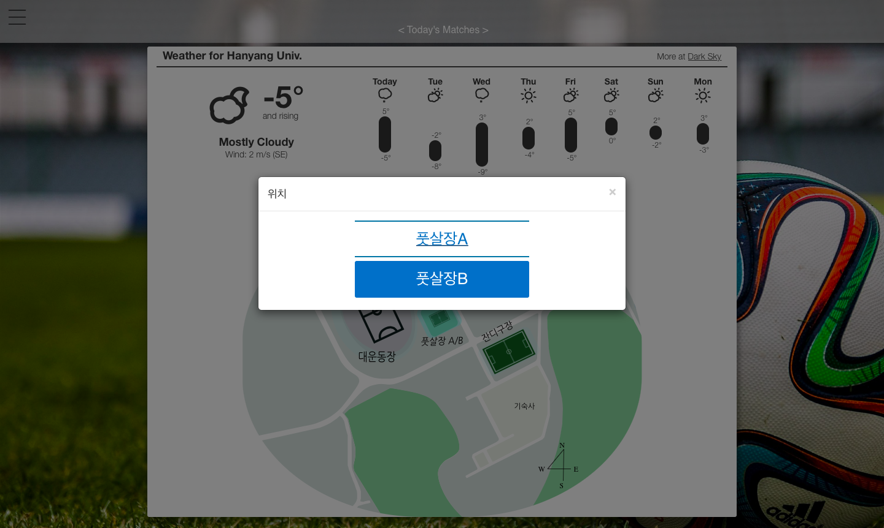

(6) Confirmation Page

Using tables to confirm the schedule, the background color was divided into graduations by increasing the number of odd numbers, thus assigning the background color to gray.

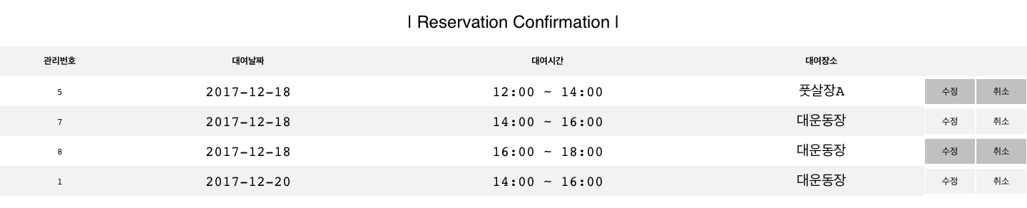

1-2. Architecture

(1) Main Page

If you go to the main page first, you can see two buttons that are the most common button in the center of the screen. The " Confirmation " and the " Rental Go " buttons, respectively, are the buttons for checking the schedule status and the progress of the booking. There are buttons on the upper left hand corner to go to more pages by clicking on the menu icon. The first menu on the main tab is the menu that can be returned to the main page of the main page, and the About Us menu is a button on the page that contains what this webpage has to do with the page and who is there. Second, the Login menu on the USER tab is a menu where users can log in to the homepage. Once a user logs in, the Logout menu and My Page menu are available for logout. The My Page menu is then clicked on to the user's My Page. As mentioned previously, the message will be sent to the counterpart team to save the opponents team, and you can see the message sent to you on the same page. Finally, the Futsal Form menu and the Futsal Field Rental Menu on the RENTAL tab enable confirmation of the reservation status of each reservation, such as the Confirmation and Redeem button, respectively, and the reservation status of the reservation.

(2) About Us Page

Welcome to the webpage. Site Information describes what the site is doing and in what order to rent it. Developers provides an introduction to, and introduces the developer team members of the site. Introductions briefly describe what part of the role you took, and links to the feather hub page are attached. Finally, contact has shown a brief overview of the contacts for this site.

(3) Confirmation Page

This is a page that allows users to confirm what they have booked. If the user wants to modify his or her reservation, he/she can proceed on this page and proceed with modifications. If you press the Cancel Schedule button, the contents of the booking will disappear and other users will be able to schedule the booking on that date. If you click the Schedule Correction button, you can change the reservation by selecting a schedule to go to the reservation detail page, including the date that you scheduled.

(4) Futsal Field Rental Page

After the user has logged in with their ID, they can go to the Reservation Page and choose one of the following locations : a farmyard, a stadium, or a lawn stadium. Selecting a location enters the Reservation Page where you can select a rental date and time. If no date is selected, today's date is selected by default. Once a schedule has been selected, a box will appear to select the purpose of use and enter a unit name. You can also choose whether or not to notify the site of your own competition schedule.

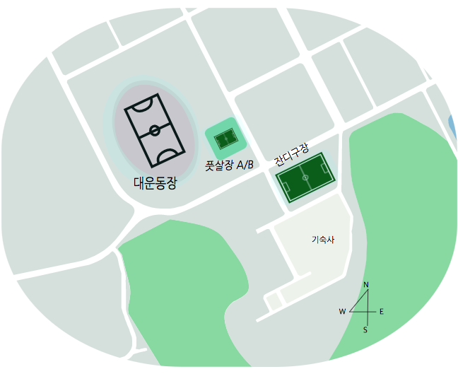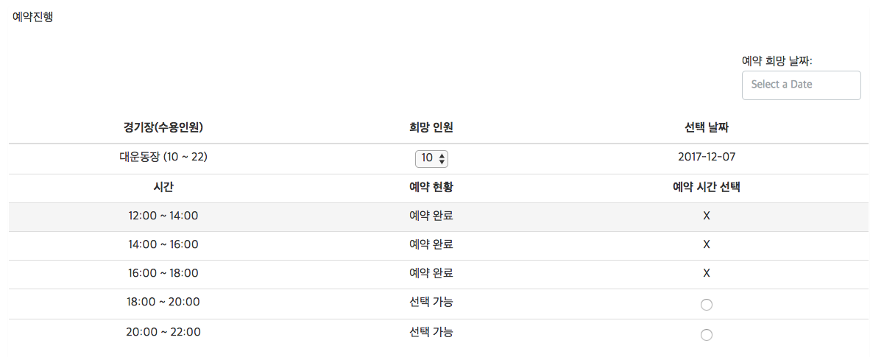

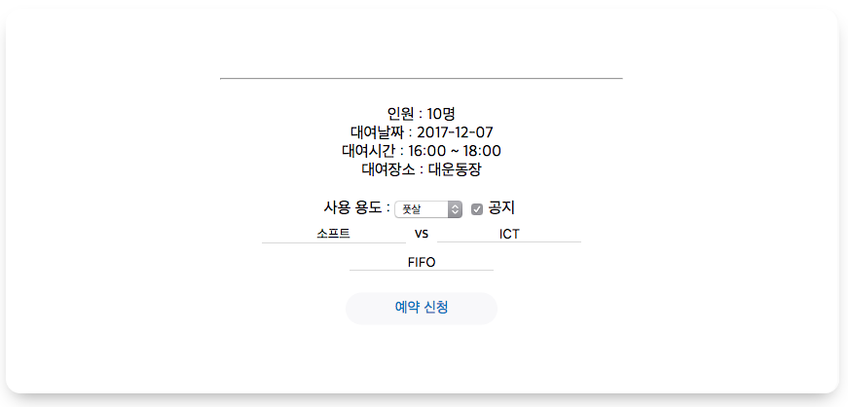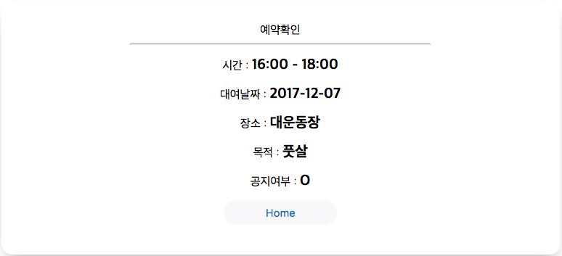

When choosing a reservation date, the calendar was opened, which led to the Java script code as open source. This code has been amended from today until two months after the date.

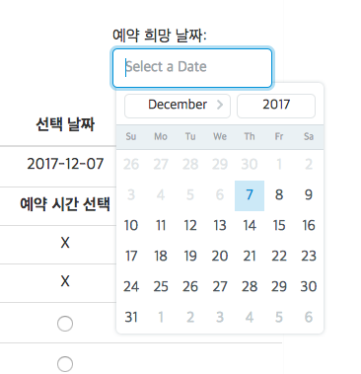

(5) My Page / Matching Request Page

These two pages are those with the matching functionality implemented previously. When the user wants to use the other team's rescue system, a message is written to save the other team. The Matching Request page is where you can see a list of all messages that are saving the other team. From this page, you can view the message by viewing the ' View ' button by viewing the ' View ' button, and then press the ' View Information ' button to confirm the booking information and send a request for a match. When the user logs in, the page you see can see messages from the other team when the other side has accepted its match request. You can make a reservation right away by pressing the ' Book Me ' button after confirming the message.

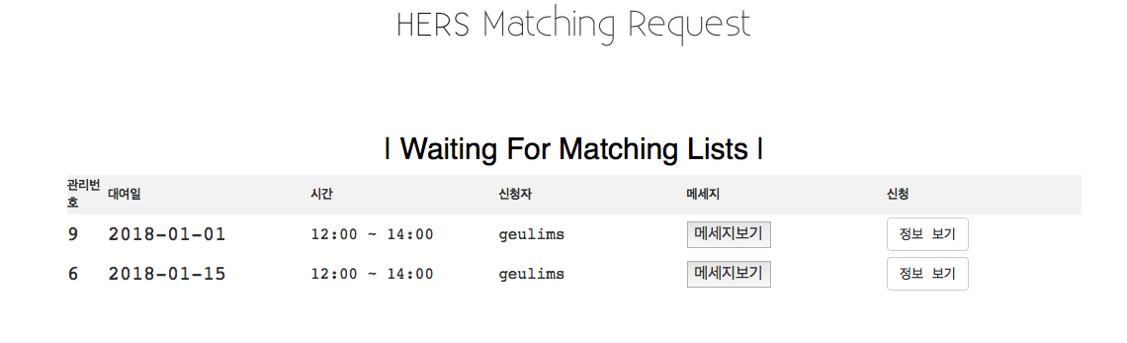

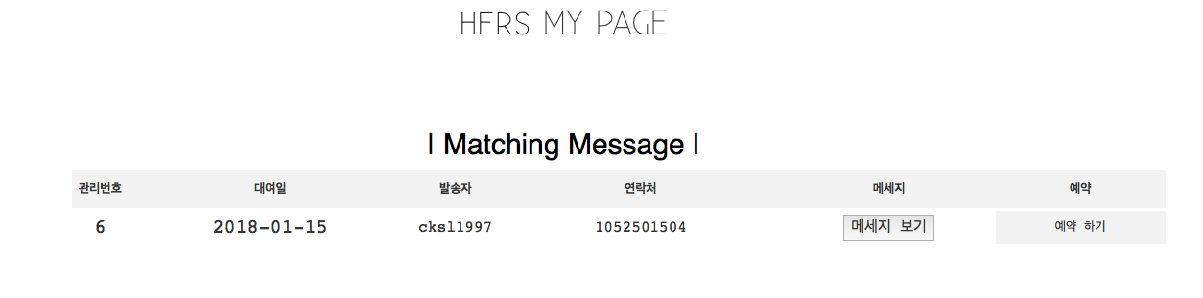

**2. Back End**

2-1. Design – Database Schema

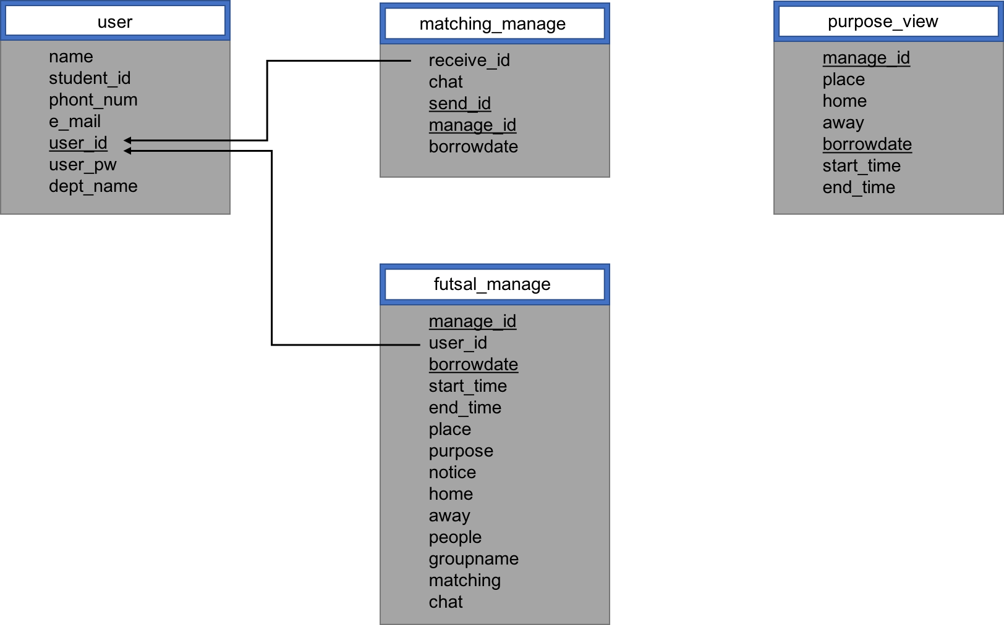

2-2. Architecture

(1) Schema 구성

- user table : Member information  
- futsal_manage table : reservation details  
- purpose_view table : details to notify  
- matching_manage table : related information such as messages related to matching functionality

When a user subscribes to a member, the user's information is stored in the user table. Because the user logs in and uses the reservation and matching system, each of the functions is stored in the futsal _ manage tables and matching_manage tables. This will result in the user being imported from the user table and the user's information, reservation and matching details.

(2) Insert Manager Account

insert into user values('HERS',0,0,'0','HERS','HERS','0');

2-3. Functionalities

(1) Login / Logout / Sign Up / Forgot

Membership is required for the first user who visits the building to proceed the reservation. The member entered the input and entered the information entered into the database after checking the information entered into the database. Login and log functionality were used by php sessions. If the input value matches the information contained in the database, it is inserted into the php session, and press out the log to finish the session with the php session destory. It also enabled users to log in on a log in any page once they log in. ID and off-duty search enabled ID or off - duty details to appear after pop-up windows (Modal) using the form ajax request json. When a user tried to log in while already logged in, a pop-up window was displayed to the user stating that they had already logged in.

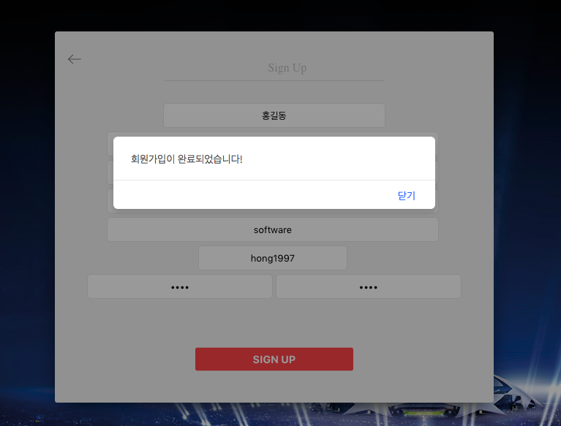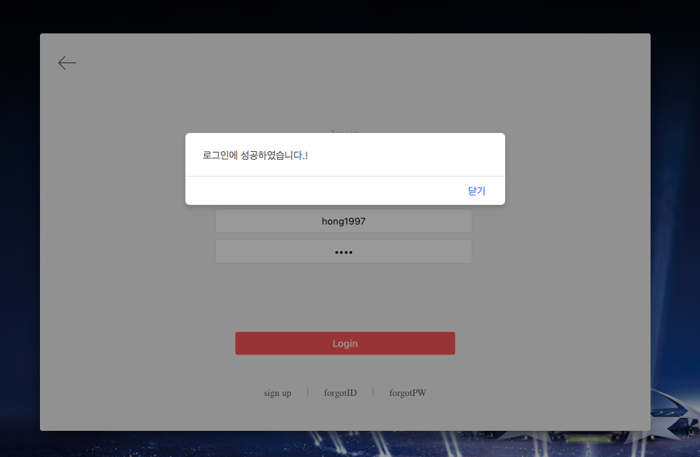

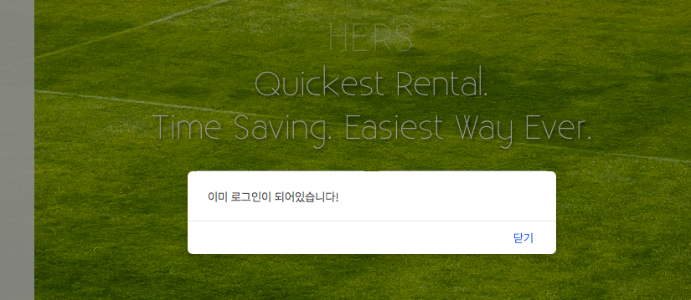

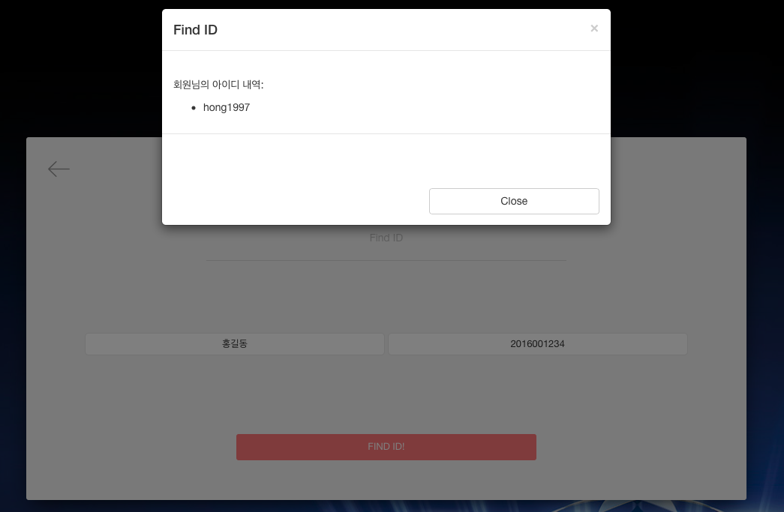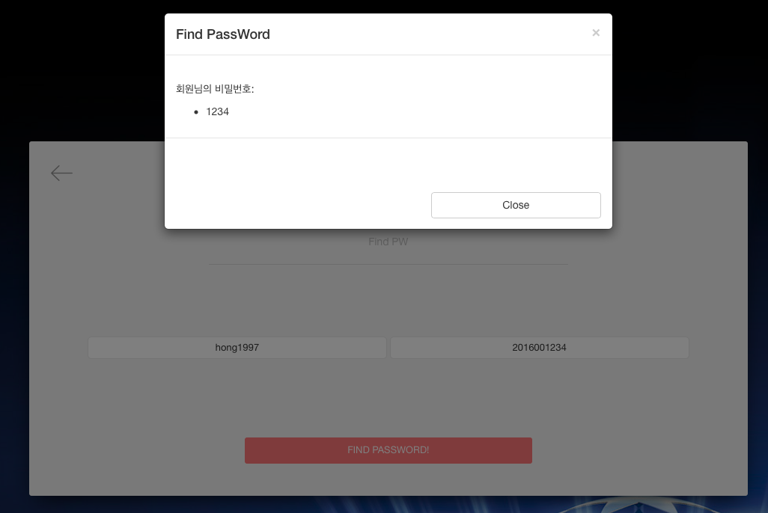

(2) Confirmation Page – Modify a schedule

When carrying out a reservation amendment, the previous reservation details were called in for the amendment rather than the new reservation being made from scratch. All information is called up from the date, time, notice, group name to use, and by submitting the manage_id and borrowdate of the corresponding reservation details to the session, the corresponding information was obtained from the database.

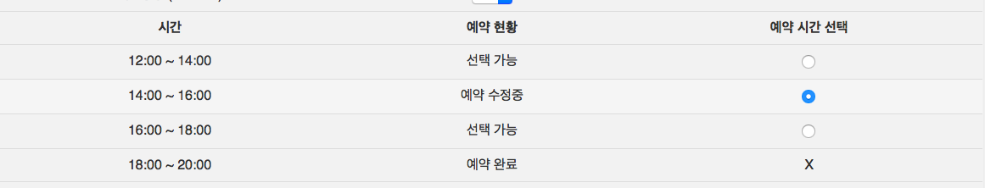

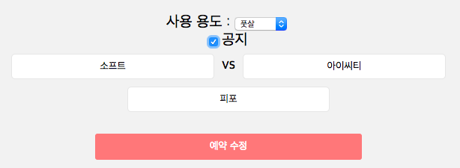

As shown in the picture above, previous reservation details are called in for modification in this state. In addition, the status of the previous reservation is displayed as ' Modification of reservation in progress '.

(3) Notice

When the user was checking the schedule, he provided home and leaves the notification buttons. The data is then intersected in the purpose_viewing table as well as the futsal _ manage table. When entering the reservation page, the data from the database is imported from the Purpose_View date to the purpose_view, and leaves the notice in the home, away day, and time. Notice is displayed in ascending chronological order.



(4) Matching

From today's date, the user can save the opposing team from two weeks later.

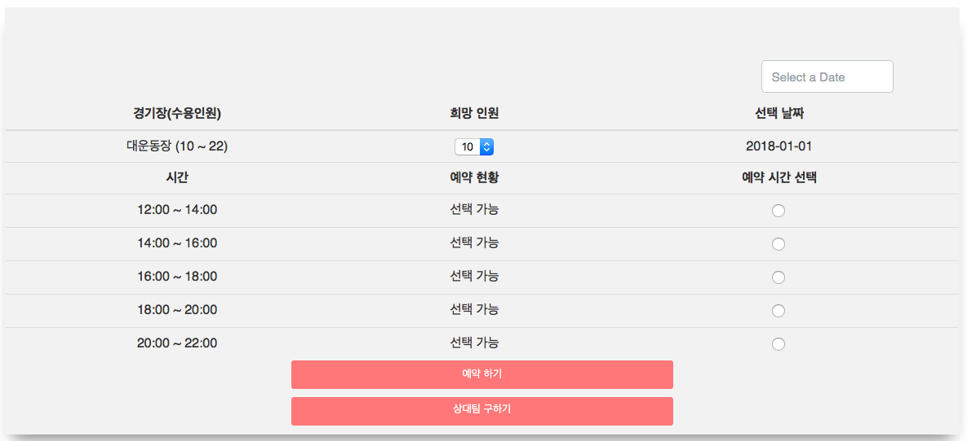

(Photo : Current date 2017 / 18 / 18, 2 weeks from no.110101, the competitor's save button will be opened from the schedule of the engines101.)

When you press the Save Team button, you open a message to enter a message, and when prompted, the message and information are entered in the futsal _ manage table.

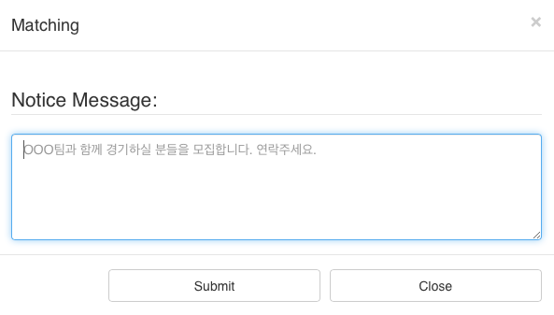

When the Sub - play button is completed by pressing the submittal button, the status of the reservation table corresponding to the date and time of the booking is changed, and the ' View Information ' button is generated instead of the radio button on the right hand side.

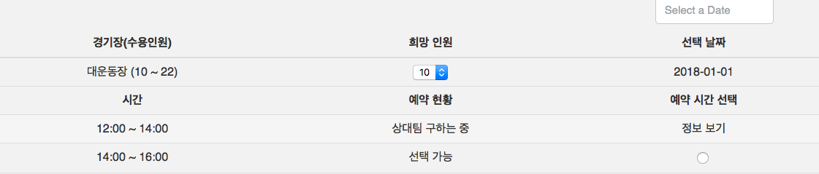

When you click on the ' View Information ' button, a pop-up window appears, and when the message is entered and submitted, the information and message is entered into the matching_manage table.

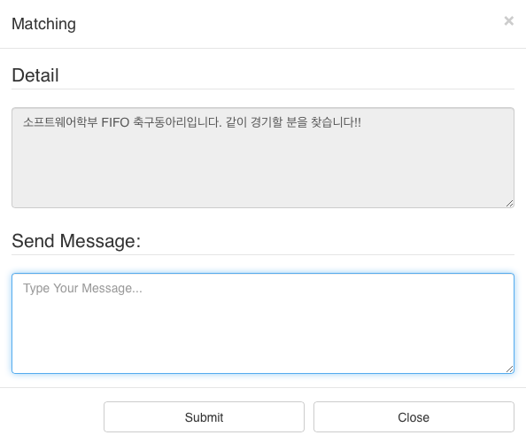

The messages sent are then found in the users My Page, which is the recipient of the message.At this time, if the applicant's competition is accepted, the reservation can be made according to the schedule, using the booking button directly to the right.

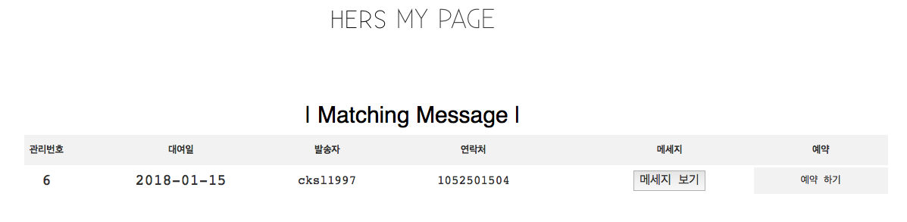

**[4] Conclusion**

The advantages and characteristics of the plant and yard reservation system to be implemented can be summarized exactly three. First, arrangements are much easier to prepare for existing arrangements.. Users can make reservations at their convenience whenever they have an Internet connection anywhere. This is much more convenient because it is chosen from a few options, rather than written by a certain number of options. Second, it is convenient to manage users because it has a login function. Login function saves user information, which can be used to call up the user's information per reservation. This could prevent cases that could be misused based on anonymity on the Internet. Third, communication functions and matching functions allow users to communicate with each other. Adding capabilities to a system that can end up with a simple reservation management system will enable users to communicate with users and users, enabling them to interact with the system for a much broader variety of purposes. Implementing these systems as Web applications will help students make reservations and enjoy sports in a more convenient way.

Web Project Github : <https://github.com/Seogeurim/Web-Application-HERS>